# CS 255 System Design Document

.

## UML Diagrams

### UML Use Case Diagram

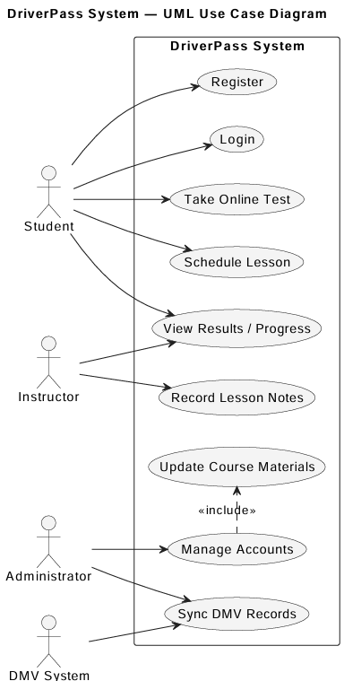

### UML Activity Diagrams

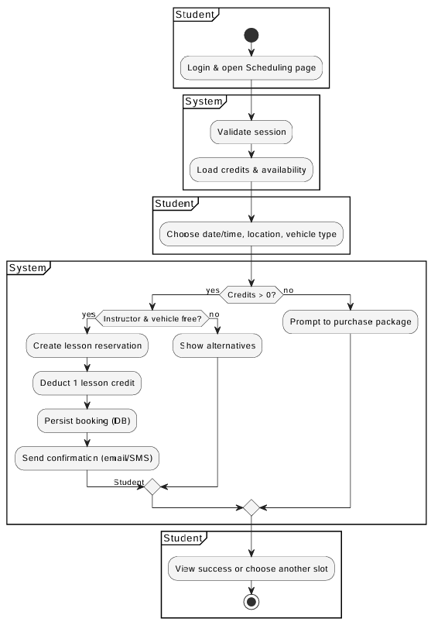

### UML Sequence Diagram

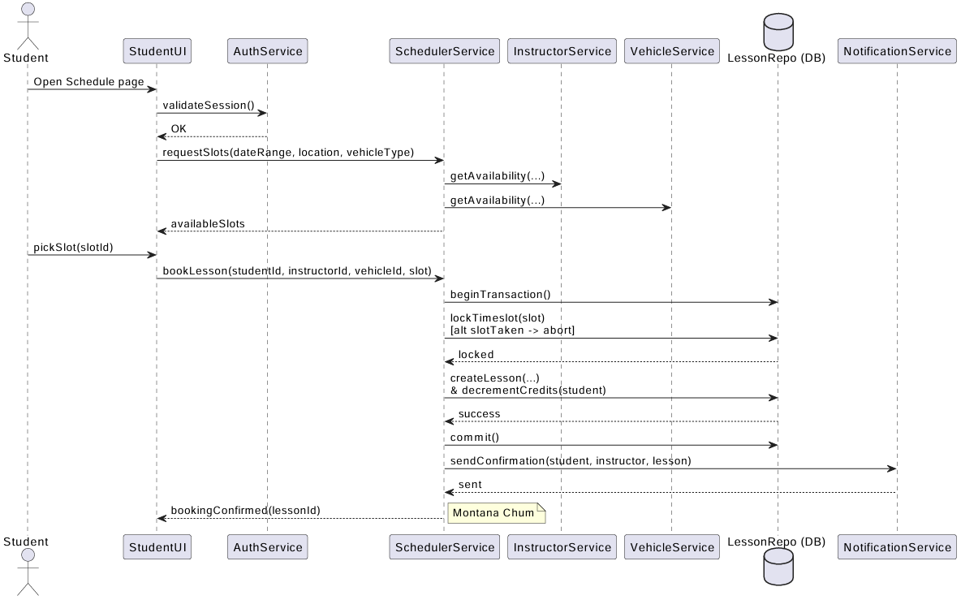

### UML Class Diagram

## Technical Requirements

The DriverPass system is designed to help students schedule driving lessons, take online tests, and track their progress. The following diagrams show how the system works and how users interact with it. The use case diagram shows the main users and what they can do. Students can make an account, buy a package, book lessons, and take practice tests. Instructors can check their schedules and update lesson notes. Admins can manage users, vehicles, and packages. The first activity diagram shows how a student books a driving lesson. The student logs in, picks a package, checks available times, pays, and gets confirmation. The second activity diagram shows how a student takes a practice test. The student selects a test, answers questions, and submits it. The system gives a score and saves the results. The sequence diagram shows what happens when a student books a lesson. The student sends a request, the system checks the schedule, assigns an instructor and car, processes payment, and sends a confirmation message.

The class diagram shows the main parts of the system, like Student, Instructor, Lesson, Vehicle, and Admin. Each part has details such as names or IDs. For example, one student can have many lessons, and each lesson belongs to one instructor. The DriverPass system will be a web app hosted on the cloud. It will use a web server, a database, and internet access for users. The system will run on common devices like laptops, tablets, or phones. The software will use HTML, CSS, and JavaScript for the front end, and Python or Java for the back end. Data will be stored in a MySQL database. The system will use HTTPS for security and have backups to protect information.